St. Josaphat Church celebrates 50 years
Post-Tribune (IN) – Saturday, January 3, 2009
Author: Sue Ellen Ross, Post-Tribune correspondent
MUNSTER – St. Josaphat Ukrainian Catholic Church celebrated 50 years in existence in 2008. The church commemorated recently with a special service and dinner, which included an exhibit of past years set up by religious education director Mary Ann Vaughn.
“The first meeting to organize a Ukrainian Catholic Mission Church was held at the home of Theodore Dzioba on Nov. 30, 1958, with Rev. Joseph Shary,” Vaughn said. “Attending were Mr. and Mrs. Elias Petryk, Stefan Pylypczak, John Luszczak, John Krysa, Nicolai Luciw and George Petryna and Joseph Lucyk.”
Another meeting the following month hosted a group of 36 people along with the Rev. Shary, the pastor of St. Joseph Ukrainian Catholic Church of Chicago. At that time, the newly established church was named St. Josaphat.
Lucyk, 86, remembers those meetings well.
“There was no Ukrainian church that was Catholic so we began talking about this,” the East Chicago resident said. “We had nothing – no money, no property, but the families did pledge.”
Following through on those pledges has led to the growth of the church – from those first seven families to almost 130 families today.
“I am proud to see the church has become so successful,” Lucyk said. “You have to be devoted. A push was needed at the beginning, but there was support all along the way.”
In the early years, there were many Ukrainian-oriented activities, such as Ukrainian language and dancing lessons for children and Ukrainian scouting groups. As many in the community were relatively newly arrived to the United States, there was a greater desire to maintain their Ukrainian culture, Vaughn explained.
Church services at St. Josaphat have changed somewhat in the last half-century.
In the early years, they were spoken or sung in Old Slavonic. By the 1960s, there was a switch to modern Ukrainian.
The normal service, then as now, is the Liturgy of St. John Chrysostom, according to the Byzantine tradition. No musical instruments are used in Ukrainian Catholic churches. Usually, both the priest and parishioners or choir sing all parts of the service.
Reaching out to the community over the years took many forms for St. Josaphat’s.
“In 1980, the church began to sell perogies to the public as a fund-raiser,” Vaughn added. “The ladies and men of the church continue this tradition, selling their wares every Friday.”
The church in Munster originally was not as it looks today. It was important to put up the walls of the church and hall, but traditional iconography and decoration of the church was complex and costly, according to Vaughn. Over the years, there have been several additions, such as icons and a chandlier, as well as storage areas and other items.
The 50th celebration included an appearance by Bishop Richard Stephen Seminack, head of the Ukrainian Catholic Eparchy of St. Nicholas, Chicago.
For more information about St. Josaphat Ukrainian Catholic Church, call (219) 923-0984.
Key dates in history of St. Josaphat’s
November 1958: First meeting to establish a new church.
December 1958: Second meeting to confirm plans and name the new church St. Josaphat. Temporary services at a store building at 6214 Columbia Ave. in Hammond begin, with the Rev. Joseph Shary celebrating the first Liturgy.
1959: Property at 7034 Columbia Ave. in Hammond is purchased and work begins to convert that home into a church.
May 17, 1959: First Liturgy in the new church is celebrated by the Rev. Vladimir “Val” Wiwcharowsky.
August 1960: The church is dedicated by Archbishop Metropolitan the Most Rev. Constantine Bohachevsky.
Sept. 9, 1963: Property at Ridge Road and White Oak Avenue in Munster is obtained, to address the need for a rapidly expanding congregation. A new structure later was built and parishioners moved in shortly thereafter.
Presently: St. Josaphat Ukrainian Catholic Church continues to conduct services at this location, with approximately 130 households on the membership rolls.
Pastors who have served St. Josaphat’s:
The Rev. Joseph Shary, Nov. 30, 1958, to Sept. 29, 1960;
The Rev. Raymond Kostiuk, Sept. 30, 1960, to Feb. 8, 1964;
The Rev. Joseph Martyniuk, Feb. 9, 1964, to Nov. 22, 1970;
The Very Rev. Walter W. Wozniak, Nov. 23, 1970, to April 1991;
The Very Rev. Michael Stelmach, April 1991 to September 1992;
The Rev. Pavlo Hayda, October 1992 to July 1995;
The Rev. Thomas Dobrowolski, July 1995 to November 1995;
The Rev. John Hritzko, November 1995 to October 2003;
The Rev. Oleh Kryvokulsky, November 2003 to Dec. 31, 2006;
The Rev. Yaroslav Mendyuk, Jan. 1, 2007, to May 13, 2015.
The Rev. Frank Avant, May 14, 2015 to November 21, 2016.
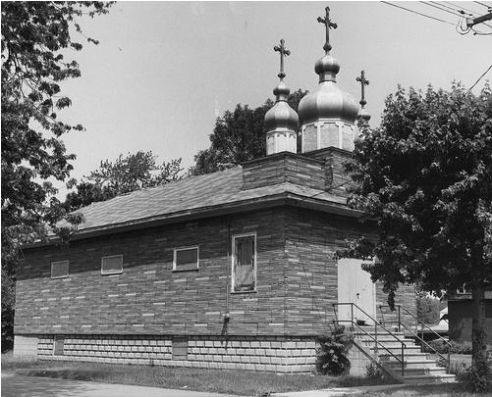
The original St. Josaphat Ukrainian Catholic Church at 7034 Columbia Ave., Hammond.
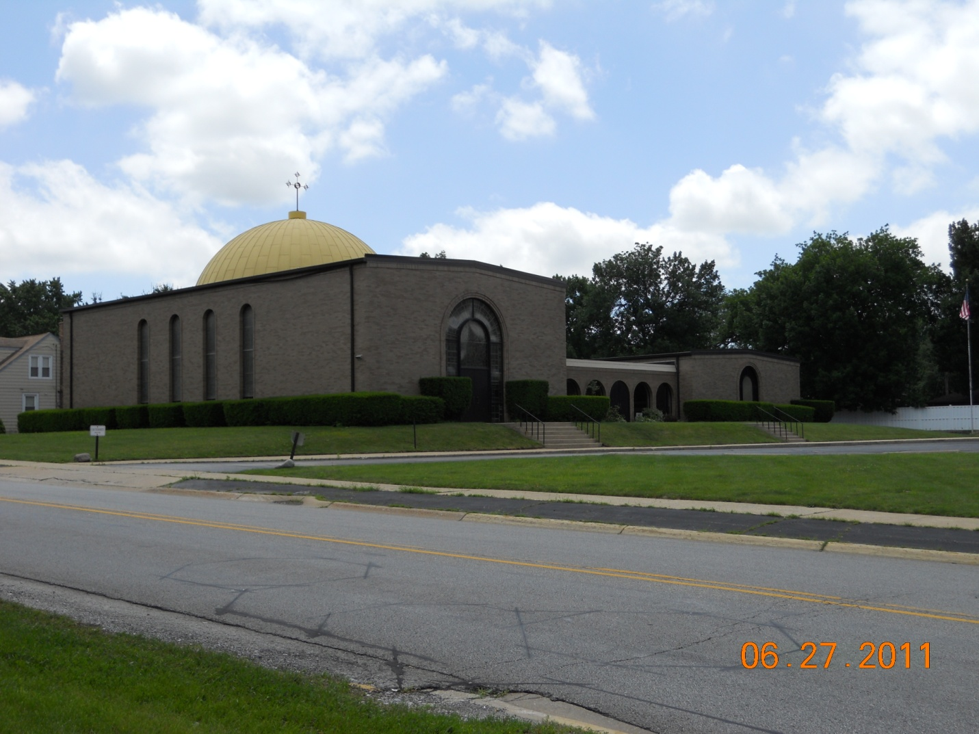
St. Josaphat Ukrainian Catholic Church at the corner of Ridge Rd. & White Oak Ave., Munster.

